**Game Menu Research**

As well as designing an appealing level, designing an appealing menu is just as crucial. The menu is typically the first thing the player sees when starting a game, and so the first impression of the game falls to this menu to give the player a feel for what the rest of the game’s atmosphere.

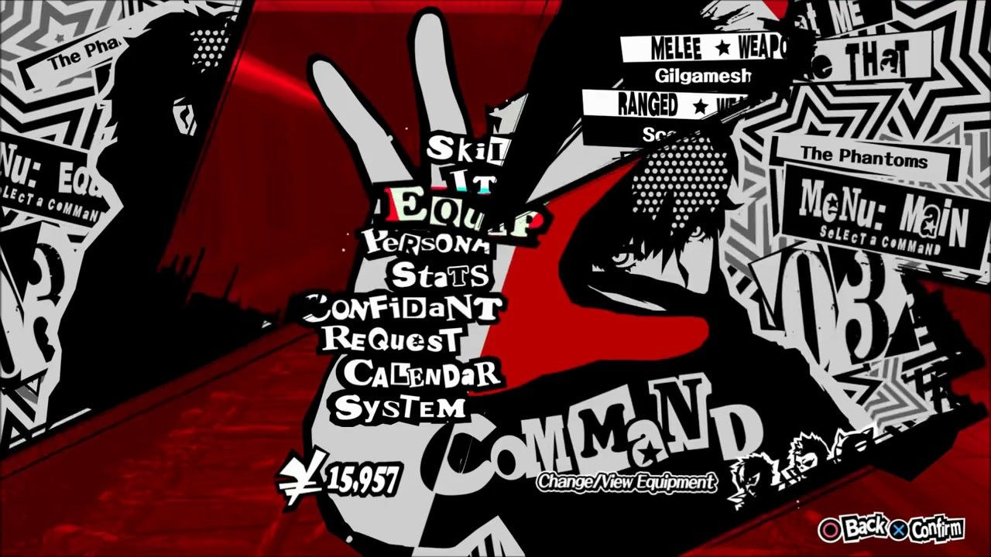In recent years, *Persona 5* has received acclaim for its menus. From a design standpoint, the menu was made bright, angular and flashy to contrast the game’s theme and gameplay of being a high school student in a dull environment.

Leading lines are used to frame the options on the menu, and the differing red colours provide contrast, so the white can stand out; this also allows for a three-tone menu that uses the negative space provided by the black to provide more dynamic shapes. The misaligned menu options allow for pattern recognition, the player can easily determine which menu option they want to select at a glance depending on how skewed from the middle the menu option they want is, for example, “Confidant” sticks out to the left more than “System” so the player will know that if they want to select “Confidant” then they select the leftmost option.

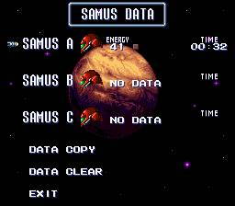*Super Metroid*’s main menu provides the opposite approach. The main information the player needs to know-their time spent playing and how much health they have-are displayed right there on the screen, so the player knows the instant they turn on the game how far they have progressed.   
  
This minimalistic design fits in with the game’s level design, too. The game’s layout is designed to be memorised so the player can complete the game faster and faster. Having the current record there on the menu shows the player how much progression they’ve made when it comes to completing the game, encouraging them to keep playing for faster times.

*Mega Man X’s* title menu is very minimalistic, but still an excellent example of how menus can be used intuitively. X (the character on the left) is used in place of cursor to select one of the menu options, and when the player selects an option he fires a large green shot at it. When actually playing the game, the player will notice that his shots look nothing like the shot from the menu, which will lead them to discover that they have a more powerful charge shot at their disposal.

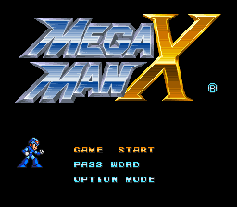The use of context clues within a menu could also be applied to not just gameplay, but to the design. While Mega Man X decides to create a stark contrast with a black background and minimal decoration, I could use background items to help the player understand the atmosphere of the game immediately, for example, the use of a background image of a military base or robotic parts (weaponry, soldier’s uniforms, gears, etc.) could give the player a nonverbal idea of what the game might be like.

To summarise, a menu should give the player the most important information and present that information in an easily digestible way. Patterns or context can be used to allow the player to navigate menus more easily by memory (for the former) and provide more background atmosphere clues (for the latter). I will use this knowledge in conjunction with design principles to design three example menus that could be used for our project.